**ASSIGNMENT – 1 --- LINUX COMMANDS:**

1. Which command is used to know the current working directory?

Command: $ pwd

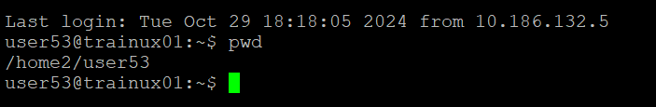

1. How would you find out its contents?

command: $ ls



3. Identify the commands with inputs to do the following

a. create a directory d1

b. create a subdirectory d2 in d1

c. change to directory d2

d. create an empty file “f1.txt”

e. display the contents of “f1.txt”

f. view the contents of d1 from current directory d2

command: a. $ mkdir d1

b. $ mkdir d1/d2

c. $ cd d1/d2

d. $ touch f1.txt

e. $ cat f1.txt

f.$ ls ..

1. Use the ls command with its options. How will you identify directories from the listing?

Command : $ ls -l

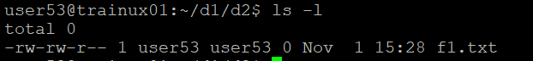

5. Use ls to do the following

a. List files with single character names.

b. List hidden files also. [ Note : Hidden files are files having name started with a “.” ]

c. Suppose there are files tb1.1, tb2.1, tb3.1, ….tb10.1. Write command to list all the files [Hint: use wild card characters]

command: a. $ ls -1

b. $ ls -a

c. $ ls tb* .1

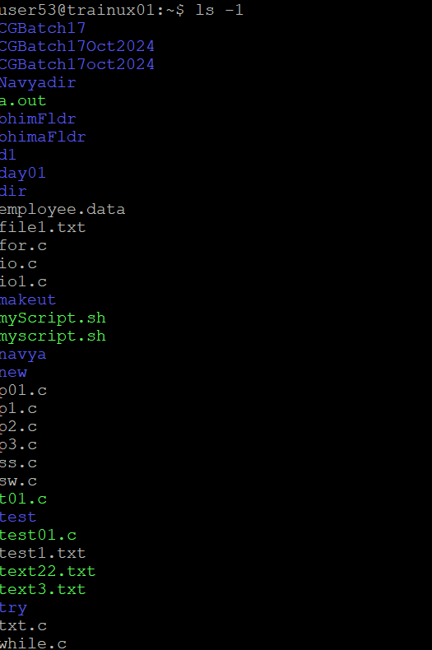

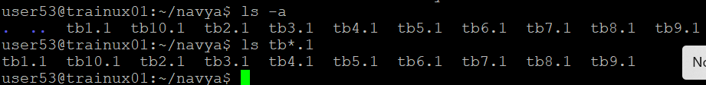

1. Write the command to list all files in descending order of their size.

Command:$ ls -lS

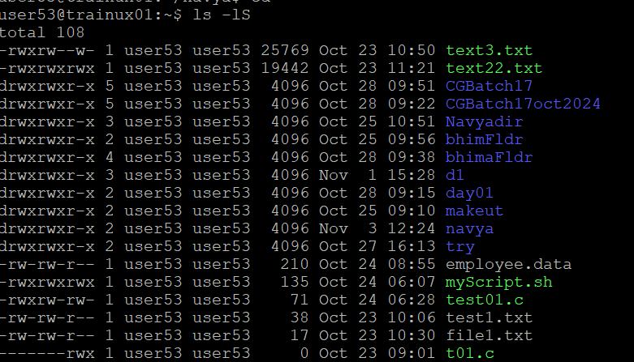

1. Suppose there are files temp1, temp2, temp3. Write command to remove the files without listing them explicitly

Command: $ rm temp*

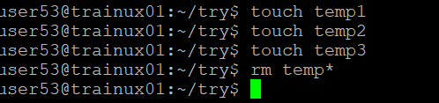

1. Which command is used to list top few lines in the file?

Command:$ head <filename>

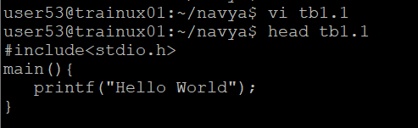

1. Create a directory “testdir”

Command: $ mkdir testdir



1. Use cp command to do the following
   1. Copy the file tb1.1 (created above) in the same directory.

Command: $ cp tb1.1 tb1.1_copy



* 1. Write a command to copy all the files i.e tb1.1,tb2.1,tb3.1,…..tb10.1 in a new directory –“new”

Command: $ mkdir new

$ cp tb*.1 new/

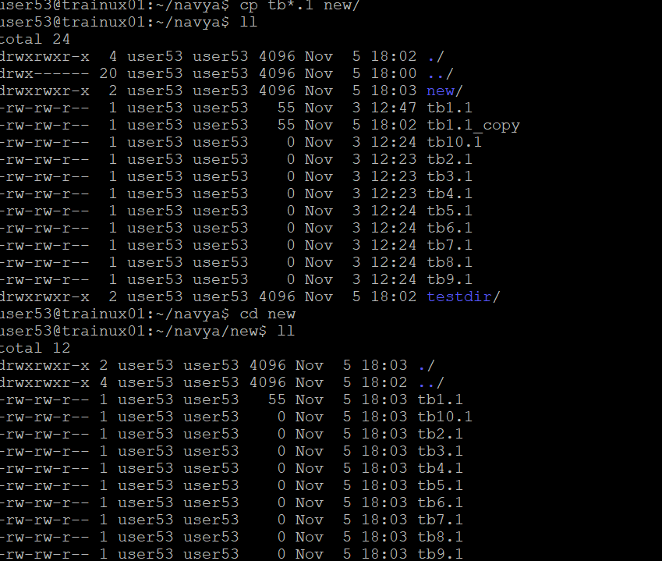

* 1. Create a subdirectory in new in named“new1”.

Command: $ mkdir new/new1

* 1. Write a command to copy selectively only tb2.1, tb6.1, tb7.1 and tb10.1 in the directory new1.

Command:$ cp tb2.1 tb6.1 tb7.1 tb10.1 new/new1/



* 1. Write a command to copy the entire directory “new” to a directory “newprogs”. [Note : use the –R option of “cp” command ]

Command: $ cp -R new newprogs

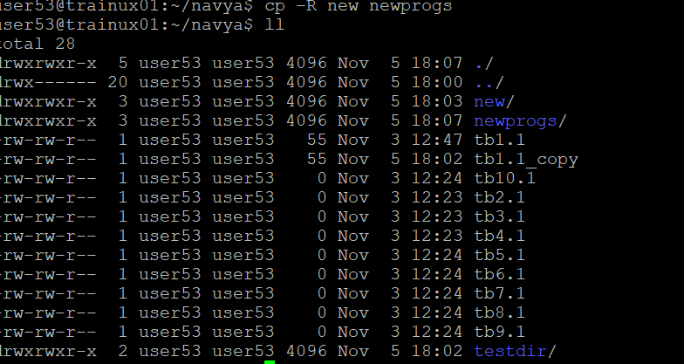

1. Find out the difference between
   1. ]“mv” & “cp”
   2. “rm”, “rmdir”
   3. “mkdir” and “mkdir -p”\

a.mv is used to move files from source to destination.

Cp is used to copy the files from source to destination

b. rm – remove is used to remove the files from source.

rmdir --- remove directory used to remove the directory

c.mkdir --- used to create a directory

mkdir -p/ ---- used to create a directory in parent directory.

1. Use a single command rmdir once to remove “testdir” and all its sub directories and files created above.

Command:$ rmdir testdir

1. Which command is used to get the manual information of a command?

Command:$ man pwd

Man command is used to get the manual information.

1. If you are not able to change to a directory what could be the likely cause?

Ans: It may be due to lack of permissions, directory may not be existing, path problems, files error.

1. Explain the differences among the following commands:  
                 a. cd /

  b. cd ..

  c. cd

  d. cd ../..

1. cd / ----- goes to the root directory
2. cd .. ----- moves to parent directory
3. cd ------ moves to home directory
4. cd ../.. ----- moves to parent directory of the parent directory.